WIN Assessments
Website: www.wincrsystem.com
Username: artimis0g45@gmail.com
Password: ER1234
Click Ready to Work Courseware
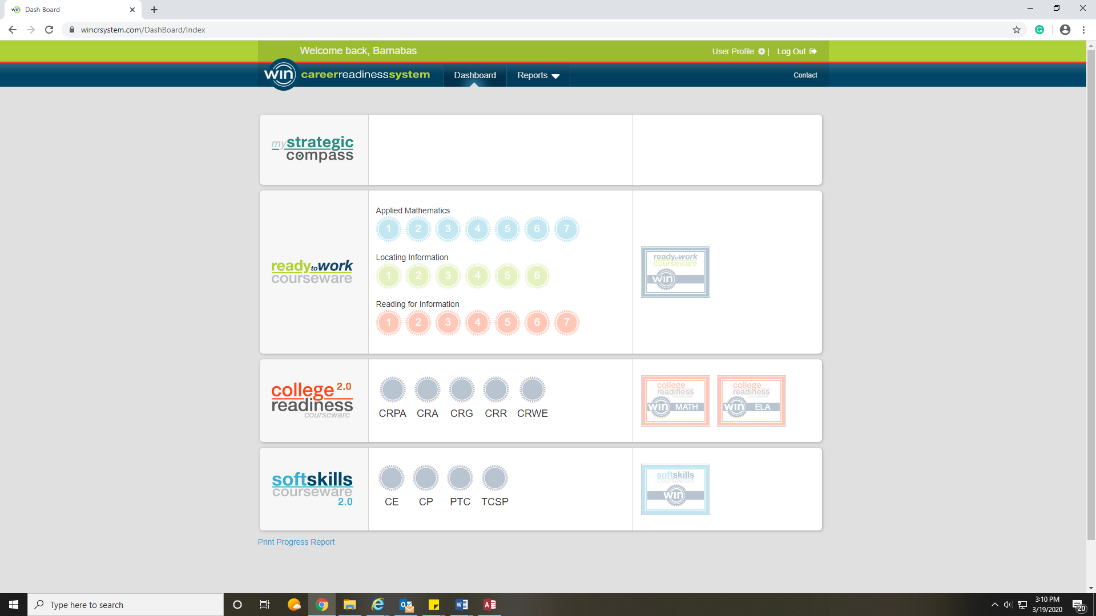
Click on Placement Test for each of the three sections. Reading for Information, Locating Information and Applied Mathematics. Each level will contain 10 questions, if you get 8 of 10 you will move on to the next level. Keep going until you score less than 80% then move on to the next placement test.
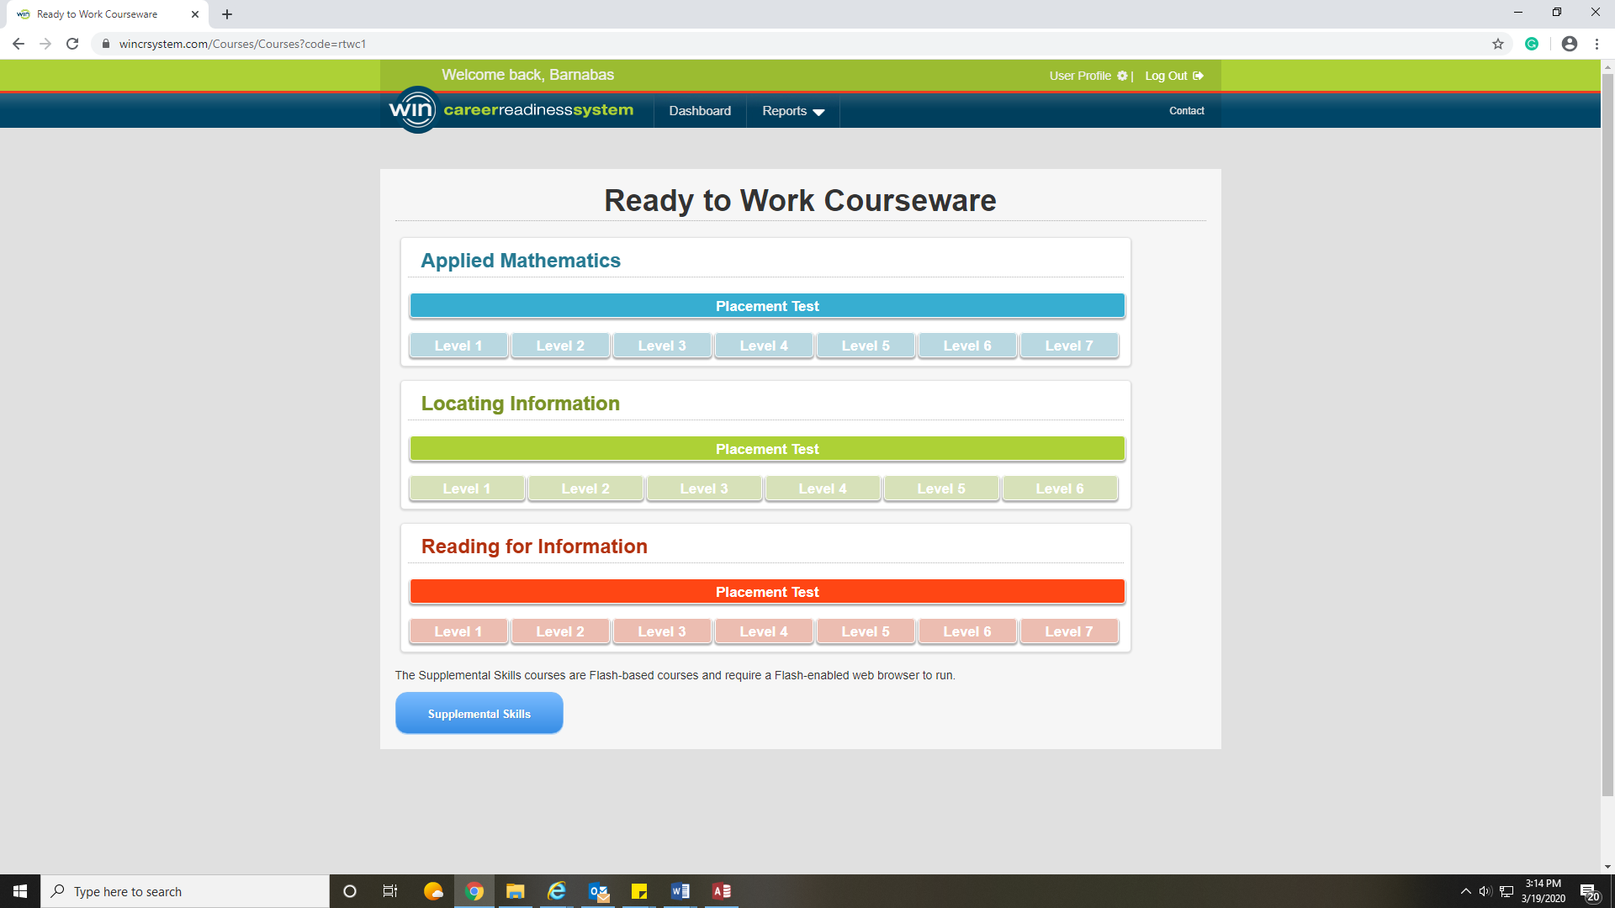

Once you complete the assessments you can go through the lessons if you would like to improve your score.

My Strategic Compass
Once you have completed the WIN Assessments you will need to complete Reality Check. (Also on WIN) From the home screen click My Strategic Compass.
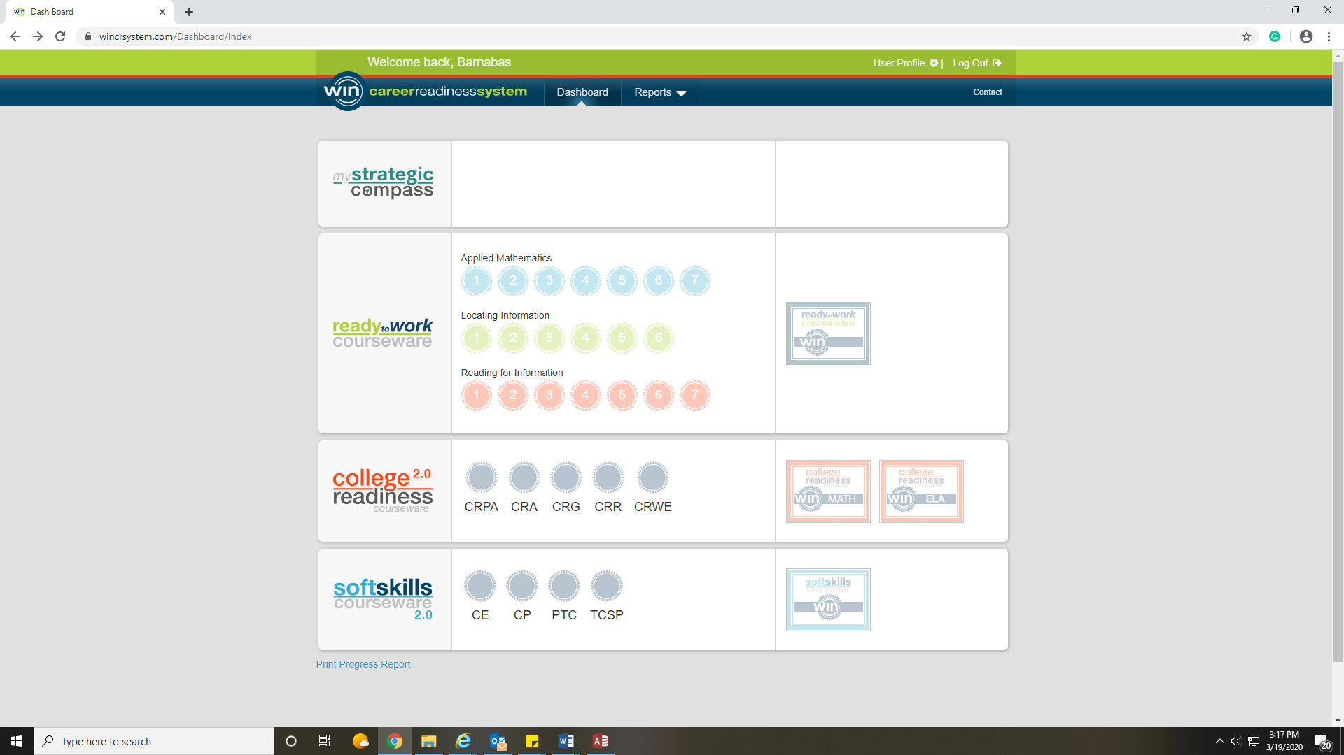
Move your mouse over the Assessments tab and click Reality Check.
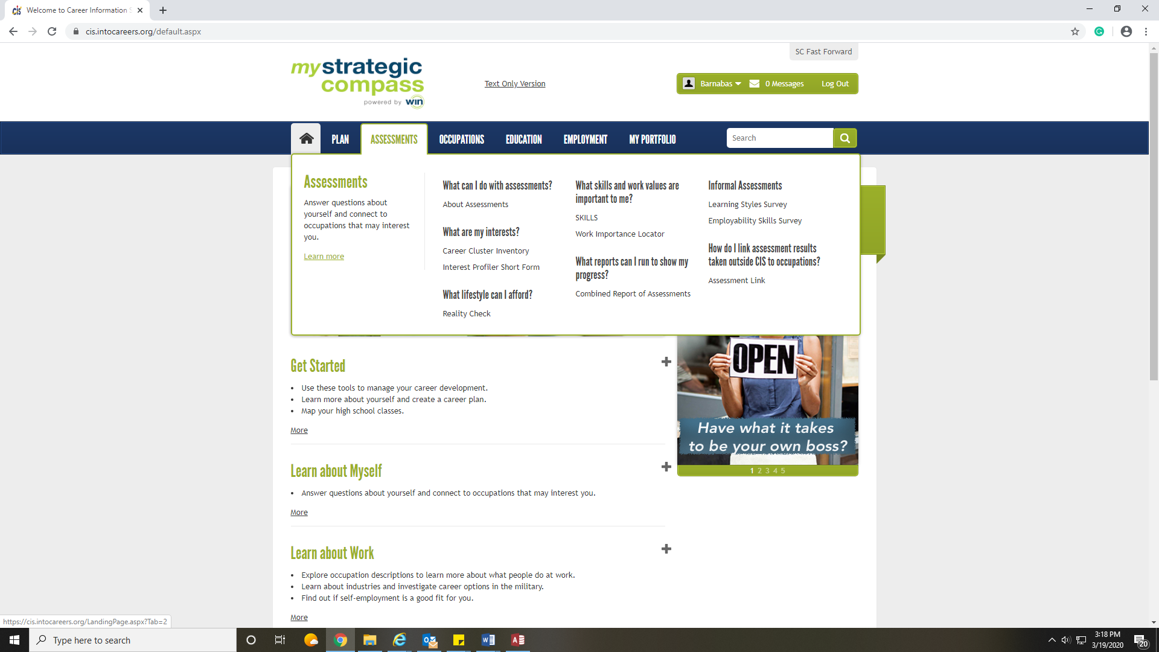

Let me know if you have any questions!
Kristen
803-343-2577
Kristen@fastforwardctc.com

