Using For Kindle

- Go to the home screen on your Kindle and locate the Skype app. Tap on the app.
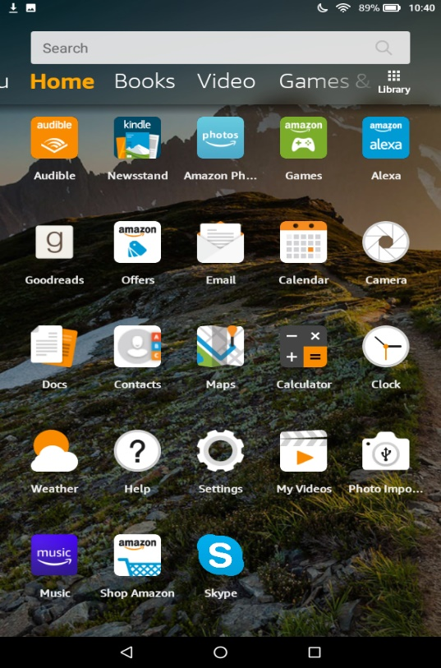
- Create a Skype account for yourself by using your phone number or your email address.
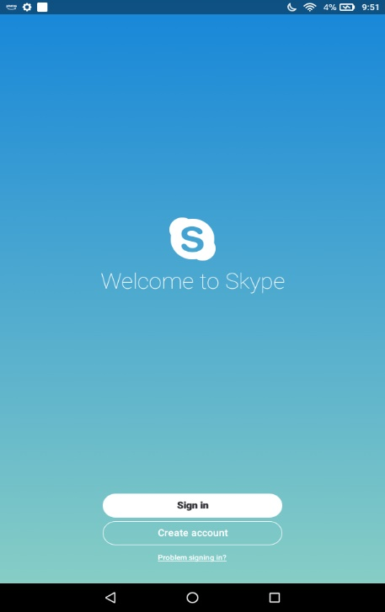

- Enter your phone number. If you would rather use your email address, click on the blue words that say ‘Use your email instead’. Tap Next to move on.
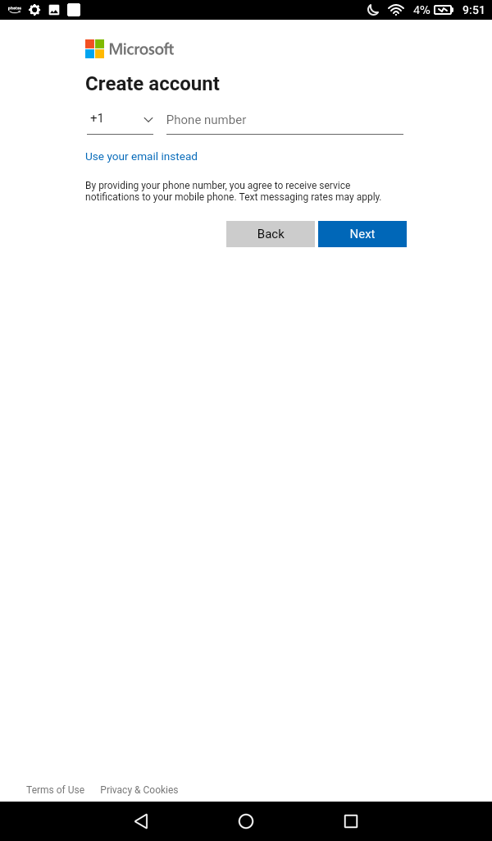
- If you used your phone number, Skype will text you a 4-digit code to verify your number. Enter the code and tap the blue button that says Next.
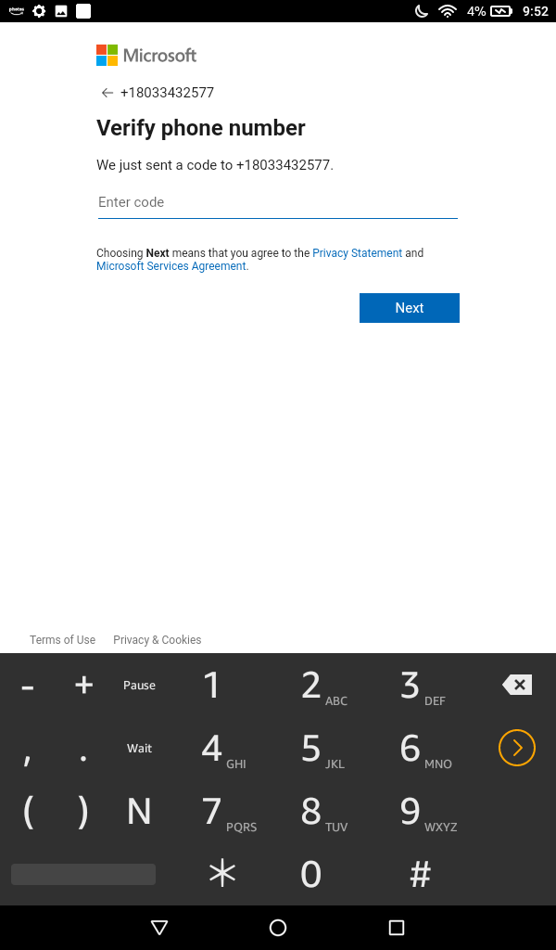
- If you opted to use an email address instead, enter your email address.
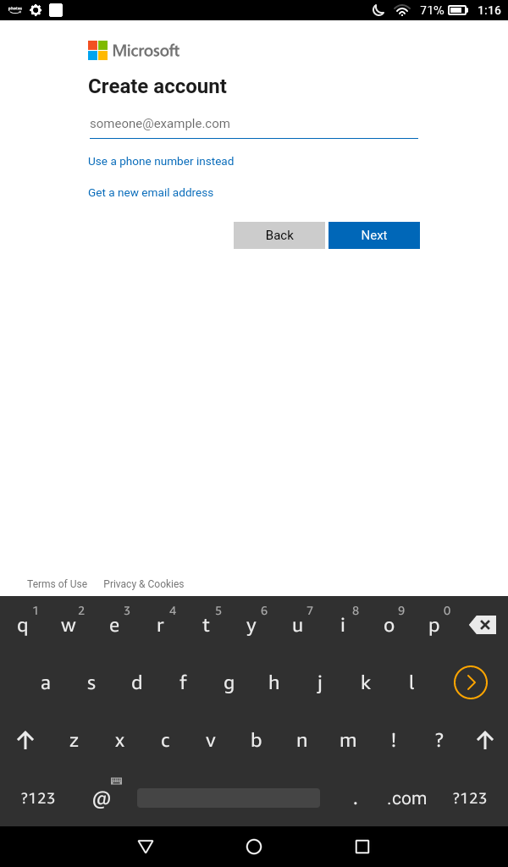
- Create a password for your account
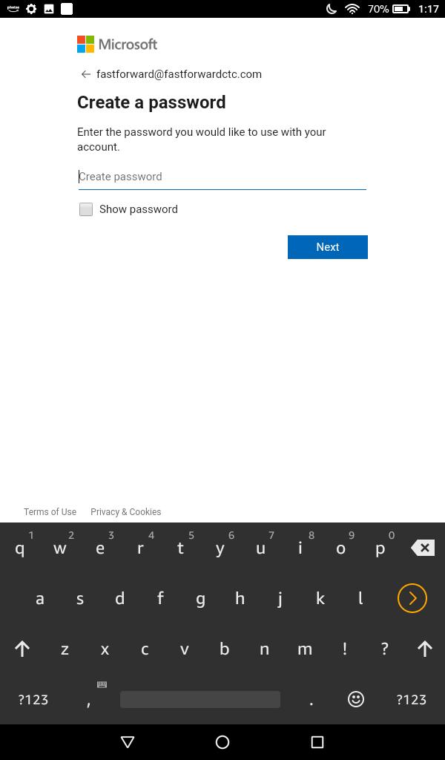
- If you use your email address, Skype will email you a code to verify your email address. Enter the code and tap the blue button that says Next.
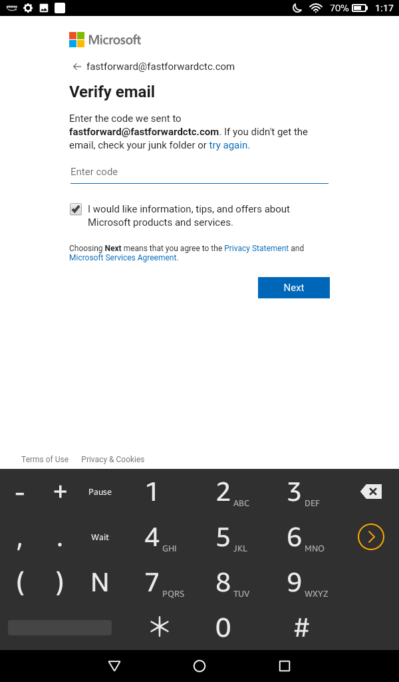
- Enter your information and tap Next
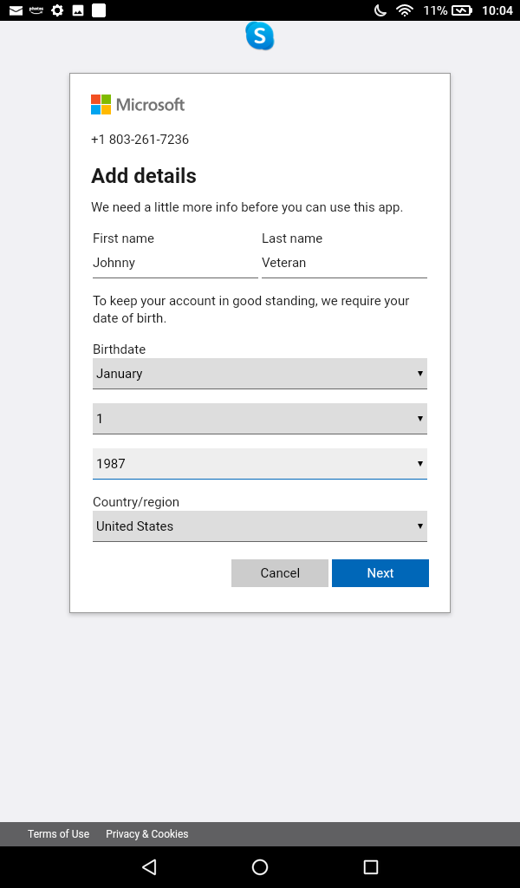
- Confirm your birthday and tap Next to complete your account setup.
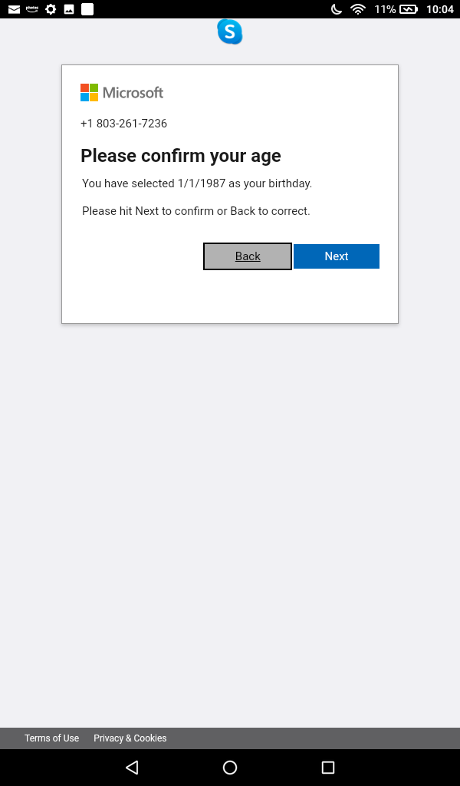
- This is the home screen for Skype. From here, you can start a text chat, start a call, or add to your contacts
- Tap on the plus sign to add a new contact.
- In the search bar at the top of the page, type the person’s name that you want to add. You can also find people by entering their Skype nickname, their phone number, or their email address.
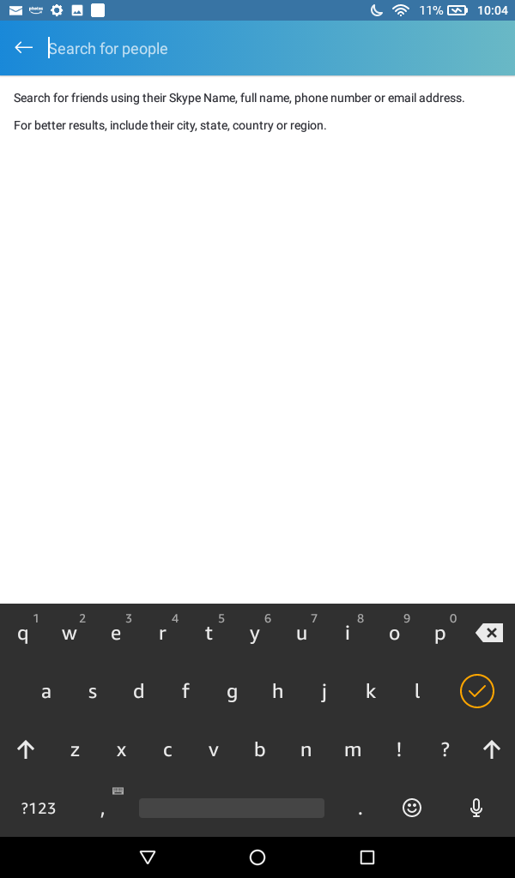
- Try adding one of the Fast Forward staff members. To do this, type in their email address in the blue bar at the top of the screen. Tap on the person’s name to connect.
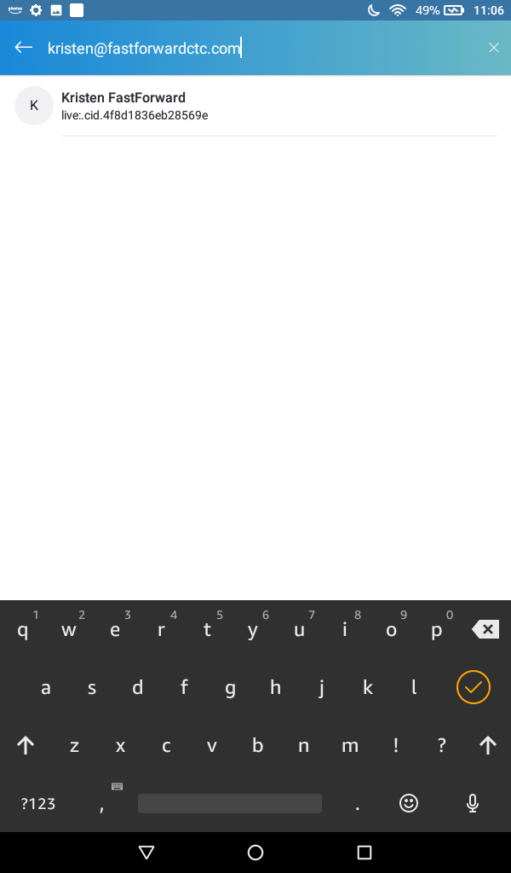
- To add the person to your contacts, tap the three dots in the top right corner of your screen. From the menu that appears, choose Add Contact.
- You can call the person by tapping on the phone icon at the top right of the screen. You can also chat with the person by typing a message into the text field at the bottom of the page.
- To make a call, tap Skype Call
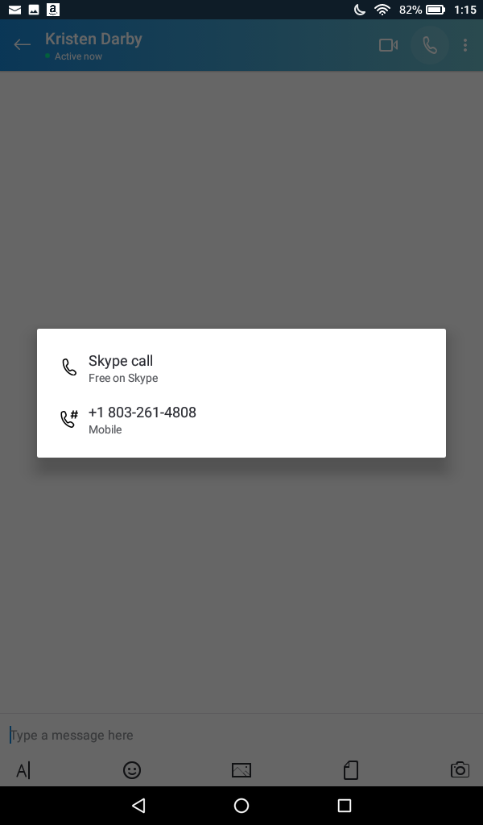
- You can use Skype to talk to a staff member like you would on a regular phone or you can use Skype to make a video call.
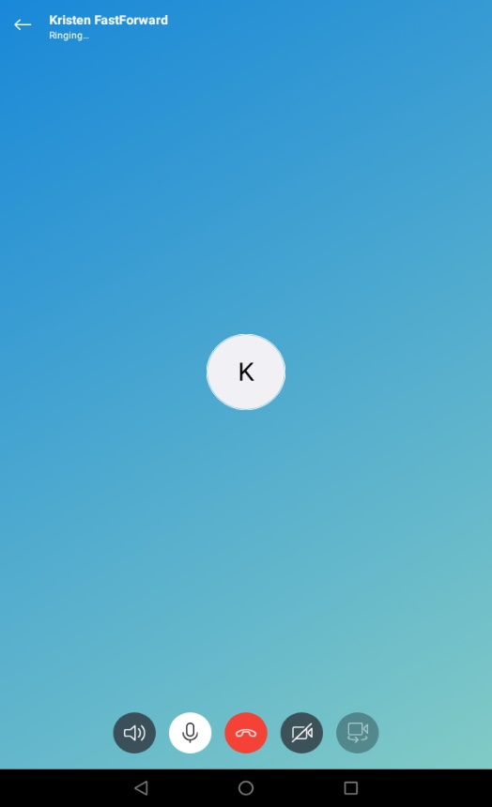
- To turn the call into a video call, tap on the camera button at the bottom of the screen
