FAST FORWARD
GMAIL SENDING EMAIL
- On the Internet, go to the website www.gmail.com.
- Enter your email address for Gmail, press the “Next” button.
- Enter your password for Gmail, press the “Sign in” button.
  - Note: Be sure to uncheck the “Stay signed in” box to keep other people from signing into your account.
- Once you log in, your screen will look similar to this screen.
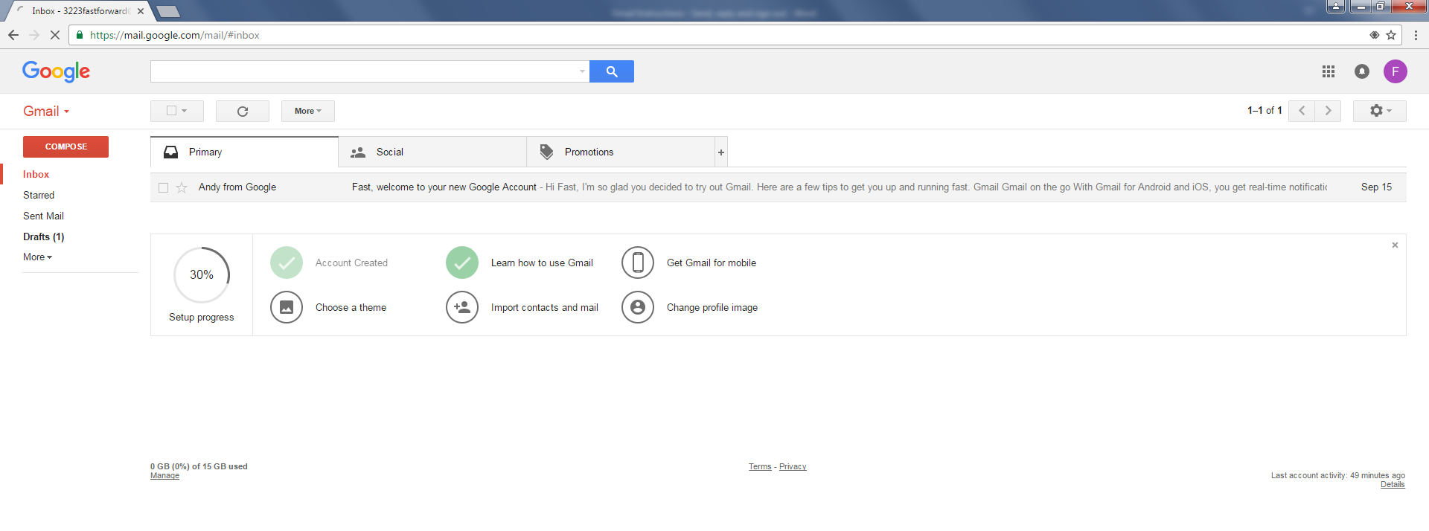
- To send a new email, click the “Compose” button.
7. Once you have everything typed, click the “Send” button.

Congratulations! Your email was sent!
6. The “New Message Box” will open
a. Type the email in the “To” line.
Remember, an email address ends with @... (@yahoo.com,
@gmail.com)
b. Add a title to the Subject line. What is the email about?
c. Type your message in the large empty box

REPLYING TO EMAIL
- After reading your email, you may want to send a reply. To send a reply, scroll all the way to the bottom of the email and click on the word that says “Reply.”
- The area where you just clicked reply changes to allow you to type in your reply. Continue by typing in your reply.
- Once you have everything typed, click the “Send” button.
- Your reply will be sent.

SIGNING OUT OF GMAIL
- Look in the top, right of the Gmail window and click on the letter inside of the colored circle.
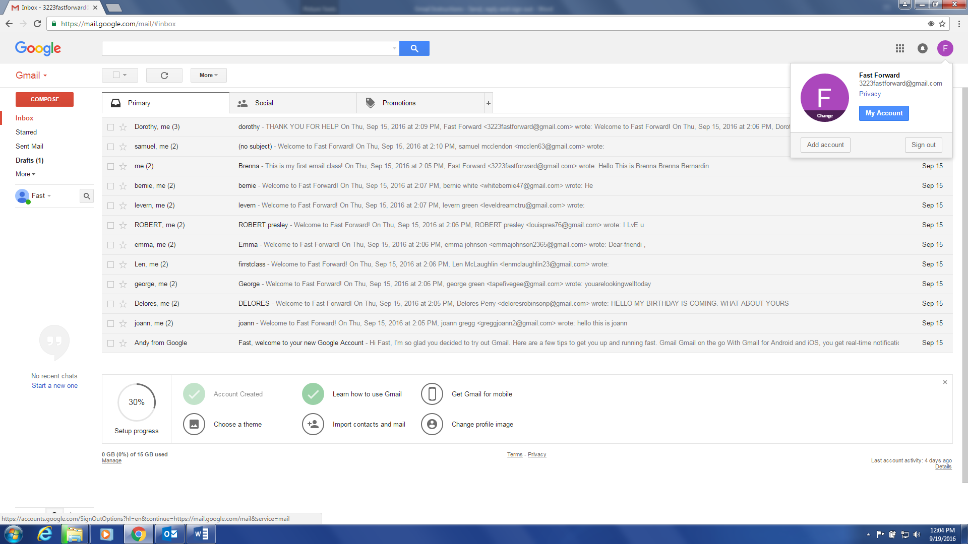
- Next, click on the “Sign Out” button.
Interested in learning more about using Gmail?
Access free lessons online at www.gcflearnfree.org/gmail

